Music Site

&

Stock Control

User Requirements

Imor Hartnett X00118631

Conor Griffin X00111602

Lee Healy X00120179

Table of Contents

**Key Interview** 2

**Survey Results** 5

**System Narrative** 8

**Use Case Model and Descriptions** 9

**Class Diagrams** 13

**Pseudocode** 14

## **Key Interview**

We undertook interviews about stock systems with the stock administrators of different companies.

**Key User, Interview with Alan McNevin, Stock Administrator at RSL ireland.**

1. What stock do you sell in your store?

**We are a refrigeration parts wholesaler so we sell items such as, copper coils, copper lengths, leak detectors, compressors, fan motors, condensing units.**

1. Is there a good stock control system implemented in the store?

**There is, everything bought is invoiced and taken off the stock showing on the computer.**

1. Does the system notify staff when stock for certain items is low?

**It does, a small warning symbol appears beside the item.**

1. Is there a way to resupply stock through this stock control system?

**Yes, all the supplier’s details are in with the stock so when it gets low we can easily get the suppliers email or phone number.**

1. If yes, how easy is this system to use?

**Very easy and handy to use.**

1. Is there a login required to manipulate stock?

**Yes there is and we all have different levels of restriction on what we can do**

1. Is there many users on this system? (All staff or managers etc.?)

**Yes about 12-15 users but there is a limit to how many staff can be on the system all at once.**

1. Who of these are able to manipulate stock? (Resupply, edit, add and delete stock?)

**Only staff in the stores can manipulate stock, no one in the office can.**

1. Would you recommend this system for companies to use?

**100%. It’s very effort and time efficient and helps a lot in the store.**

**Key User, Interview with David Moore, Duty Manager at Supervalu Walkinstown.**

1. What stock do you sell in your store?

**We are a retail store called Supervalu Walkinstown, we are Irelands largest grocery and food distributors in Ireland.**

1. Is there a good stock control system implemented in the store?

**Yes, I think our system is good , we use the Musgrave stock control system known as GOLD to keep track of all stock that we buy in and sell. This system is used so that we can keep track of stock flow and everything we stock is then transferred to the computer.**

1. Does the system notify staff when stock for certain items is low?

**It doesn’t quite do that but the system will show us what stock was ordered the previous week and what wasn’t, we can then tell if we need to order more of a certain item of stock or if we have enough of.**

1. Is there a way to resupply stock through this stock control system?

**Yes there is, we scan all the barcodes of stock that is low and this is immediately transferred to the system and all the supplier’s details are in with the stock so when the items are scanned an order is then put through for that item to be resupplied.**

1. If yes, how easy is this system to use?

**Yes it is easy to use, our stock control system does most of the work itself making it a very easy system to use.**

1. Is there a login required to manipulate stock?

**Yes there is a code you must put into each device when logging into the system.**

1. Is there many users on this system? (All staff or managers etc.?)

**It depends we have around 15 portable devices that we use to scan our products if they are low on stock, any staff member can use the system as long as they are authorized by a manager to do so.**

1. Who of these are able to manipulate stock? (Resupply, edit, add and delete stock?)

**All of our staff in the stores can manipulate stock as long as they have been authorized by a manager in the store to do so.**

1. Would you recommend this system for companies to use?

**Yes I definitely I would, It’s easy to use and does most of the work for you.**

**Music Store Key User Interview / Survey**

1. What stock do you sell in your store?

**We are a coffee shop franchise based in dublin city centre working as part of the Starbucks Corporation. Our stock sold is mainly comprised of Strbucks branded products like our selection of arabica coffee and sandwiches / wraps. We also sell outsourced fresh produce like our pastries which are delivered every morning.**

1. Is there a good stock control system implemented in the music store?

**Yes, but for the system to work it needs the supervisor on shift at the end of the week to spend the day taking stock of everything behind the bar and downstairs in the stock room.**

1. Does the system notify staff when stock for certain items was low?

**No there is no automated system the staff must count all stock to find out what produce is low on stock.**

1. Is there a way to resupply stock through this stock control system?

**Yes all our suppliers are entered on the companies computer so that the manager has direct contact with them.**

1. If yes, how easy is this system to use?

**The system still utilises an emailing process which means the manager must write inidividual emails to our suppliers which can be a time consuming process.**

1. Is there a login required to manipulate stock?

**Yes but it is very low level security. Everything is controlled by the companys computer ehich is locked by login of the user.**

1. Is there many users on this system? (All staff or managers etc?)

**There is only one single profile on the system but this profile is used by seven people. One manager and 6 shift supervisors.**

1. Who of these are able to manipulate stock? (resupply, edit, add and delete stock?)

**All supervisors and the manager are able to manipulate the stock. Barista’s do not have any access to the stock control system.**

1. Would you recommend this system for companies to use?

**No as it is not automated enough and relies on lots of staff involvment.**

## **Survey Results**

The following are the results from a recent survey we took to see what requirements we would need for our project:

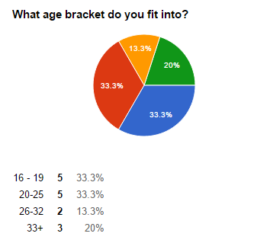

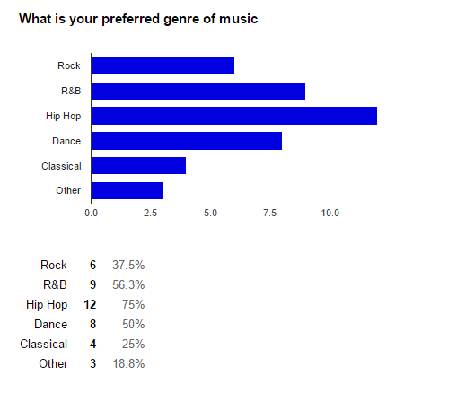

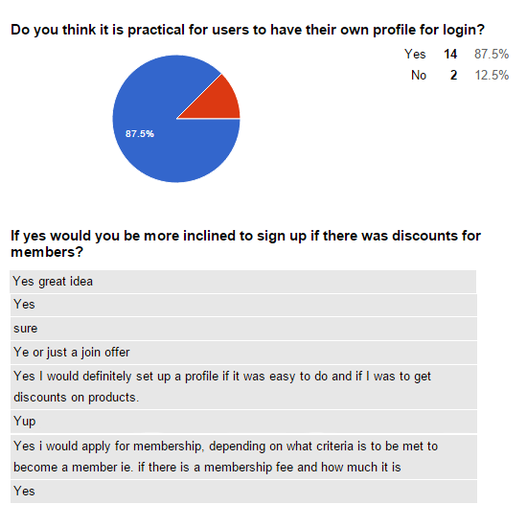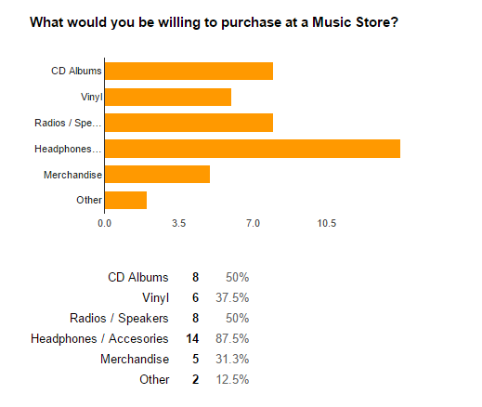

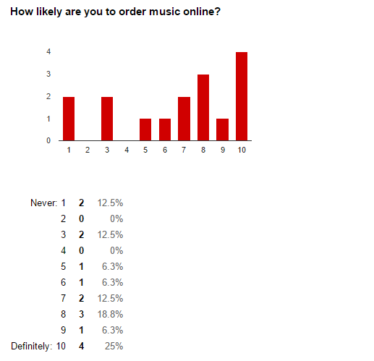

**Summary Of Results**

From the results above we established that people from all ages are willing to buy music and music accessories online. So for our Music Store Stock System we decided we should sell a broad range of items from CD’s, Vinyl’s and accessories such as headphones and speakers. Then all 3 of us, went through many different websites and looked at their structure and saw how they worked after which we decided how our own site and system would work and we then came up with a System Narrative.

## **System Narrative**

Our site is a music site and offers CD’s, Vinyl’s and other music accessories to purchasing customers. All items for sale are physical items and not to be confused with digital online downloads of music such as iTunes and Beatport etc.

**Front End**

The customer goes onto the website and the first thing they are presented with is the index page. This page tells the customer a little bit about what we do and what we have for sale. It also includes a button which brings the customer to an online catalogue of items we have for sale. After viewing the index page the customer can then either click the online catalogue button or click any of the other buttons in the navigation bar which includes another catalogue button and other buttons such as contact us and about us.

**Online Basket Checkout System**

If the customer would like to buy items from the catalogue whether it be CD’s, Vinyl Record’s or any type of accessory, they would click on the item they would like to buy and it would go into their basket/online shopping cart. This cart would contain all the items they would like to buy much like a real life physical shopping cart/basket. When the customer goes into their online basket it will bring them to a page where they could check out their items. The grand total of all the items would be displayed to the customer and a link to take them to their payment will also be shown on their display.

After the item(s) have been purchased by the customer, they will then be subtracted from their respectful stock amount. For example if there were 10 CD’s and the customer buys 2 CD’s, there will now be 8 CD’s left in stock. If the stock of the items reaches a certain low point the Stock Administrator (Manager) will receive an automatically sent warning about it from the website and then he/she will decide whether the stock is worth resupplying. If the stock is worth resupplying the Manager will send an email to the company’s supplier detailing what stock they need and the quantity of each stock to go with it.

**Stock Control System**

The Stock Administrator will have exclusive access to edit the stock on the system. They will be able to add or delete stock and also edit the name and description. Any other staff will not have these privileges because it could lead to confusion with multiple people manipulating the stock to their liking.

While the system works, in the background on the physical end there is a warehouse which holds all of our stock. The staff work in this warehouse and get orders ready as they come in. It is these members of staff that will send frequent updates of stock levels to the Stock Administrator. When a transaction happens on the front end of our system staff working in the warehouse will be notified what produce has been orders and where it is located in the warehouse. When the stock is located the staff package, label each one with their destination address and get logistics in at the end of the day to deliver all the orders.

## **Use Case Model and Descriptions**

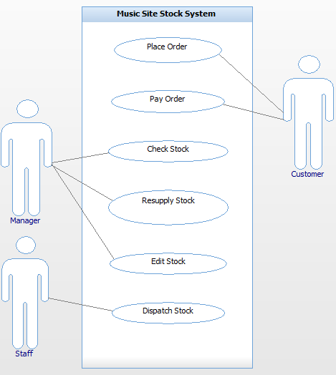

|  |  |
| --- | --- |
| Use Case: | **Place Order** |
| Actor(s): | Customer |
| Goal: | For the customer to place an order and the staff to take the order |
| Overview: | The customer enters the shop, proceeds to the counter and places an order. The staff member then takes the customer’s order. |
| Pre-  Condition: | The customer has not yet placed an order. |
| Post-  Condition: | The customer’s order has been taken by the staff member. |
| Successful  Scenario: | Step1: Customer goes onto the online shop website  Step2: Customer browses the site before purchasing  Step3: Website awaits order  Step4: Customer gives the site his/her order  Step5: Website takes the order and enters it into the system. |
| Alternative  Scenario(s): | Website is down  Stock is unavailable to customer  System is down  Connection is lost |

|  |  |
| --- | --- |
| Use Case: | **Pay Order** |
| Actor(s): | Customer |
| Goal: | For the customer to pay for his order |
| Overview: | The customer now wants to pay for the order he/she has previously placed on the website. |
| Pre-  Condition: | The customer has not yet paid for the order. |
| Post-  Condition: | The customer has paid for his/her item. |
| Successful  Scenario: | Step1: Customer proceeds to checkout after placing their order.  Step2: The site displays the total to the customer.  Step3: The site asks the customer to enter their credit card details  Step4: Customer pays by card on the website. |
| Alternative  Scenario(s): | Website is down.  Total price is calculated wrong by the site.  The customer doesn’t have a credit card  Customer has insufficient funds on their credit card. |

|  |  |
| --- | --- |
| Use Case: | **Dispatch Stock** |
| Actor(s): | Staff |
| Goal: | To export the physical stock from the stockroomto to the customer. |
| Overview: | When stock has been ordered and payment is made the staff member is responsible for physically exporting that item to the customer. |
| Pre-  Condition: | Payment has been made and stock is ready for exportation. |
| Post-  Condition: | The stock has been successfully exported to the customer. |
| Successful  Scenario: | Step1: Staff member is informed that stock has been ordered and payment has been made.  Step2: Stock is prepared by staff for exportation.  Step3: Stock is prepared for physical transportation.  Step4: Stock is exported. |
| Alternative  Scenario(s): |  |

|  |  |
| --- | --- |
| Use Case: | **Check Stock** |
| Actor(s): | Manager |
| Goal: | To look at stock levels and decide whether a certain item of stock is needed. |
| Overview: | The website looks at what items have been sold and if an item goes below a certain level of stock then the system informs the manager that stock is needed. |
| Pre-  Condition: | Stock has not been checked yet. |
| Post-  Condition: | Stock is checked and manager is informed whether certain stock is needed. |
| Successful  Scenario: | Step 1: Stock has not been checked yet.  Step 2: System checks stock when item is ordered.  Step 3: Manager is free to check stock whenever he/she wants.  Step 4: If an item is needed the manager is informed.  Step 5: Stock has been checked. |
| Alternative  Scenario(s): | Stock has not been checked by the manager, and is not ordered. |

|  |  |
| --- | --- |
| Use Case: | **Re-supply Stock** |
| Actor(s): | Manager |
| Goal: | Ordering more stock to be delivered to the warehouse |
| Overview: | Manager re-supplies stock to the store that is selling well. Manager may want to order is seasonal stock as well coming up to different calendar events. |
| Pre-  Condition: | The manager judges how much stock will be needed for the next week and places an order to keep stock levels up for the upcoming week. |
| Post-  Condition: | Stock is ordered before the stock in store in depleted. Stock is then delivered before it is needed. |
| Successful  Scenario: | Stock is delivered before the stores stock is depleted. This enables the store to be able to make the pitched sales figures for the following week. |
| Alternative  Scenario(s): | The stock re-supply is not ordered in time for a sales rush on the weekend coming up to Christmas. This puts the store under pressure to make the pitched sales for the week. |

|  |  |
| --- | --- |
| Use Case: | **Edit Stock** |
| Actor(s): | Manager |
| Goal: | To be able to edit stock (stock item names, descriptions, prices, delete stock) |
| Overview: | The manager edits certain items like the names and descriptions of items and also the changes the prices of certain items |
| Pre-  Condition: | Stock items have not been edited |
| Post-  Condition: | Stock items have been edited |
| Successful  Scenario: | Step1: Managers is on the stock database.  Step2: Manager sees a typo in one of the stock’s description, name or price.  Step3: The manager clicks on the edit button.  Step4: The manager corrects the error in the name, description or price.  Step5: All changes are saved by the manager. |
| Alternative  Scenario | Stock database is down |

## **Class Diagrams**

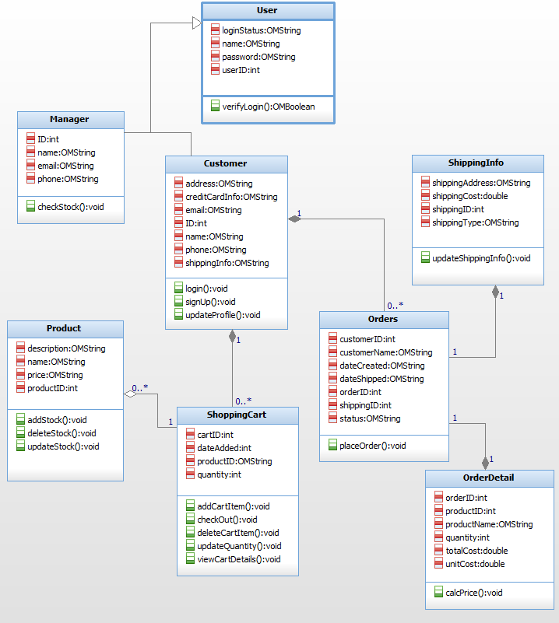

## **Pseudocode**

**Remove Stock**

*//Customer buys their items and the items are removed from stock*

**Inputs: (Name: Type:)**

stockAmount :int

itemsAmount :int

**Constants:**

LOW_STOCK :int = 5

**Begin:**

**OUTPUT**   (How many would you like to purchase?)

**INPUT**      itemsAmount

stockAmount -= itemsAmount

**IF**(StockAmount **<=** LOW_STOCK)

**OUTPUT** (to stock administrator) (Warning, low stock on item: )

**ELSE**

Stock removed successfully.

**END IF**

**End.**